PTWS 130

USP/EP Tablet Dissolution Testing Instrument

PTWS 130 is a 6-position, compact tablet dissolution testing instrument for solid dosage forms as described in USP chapter <711/724> and EP section<2.9.3/4> as well as the BP, DAB and Japanese Pharmacopeia section <15>. The S-Variant offers independent stirrer speed control for each of the six testing stations.
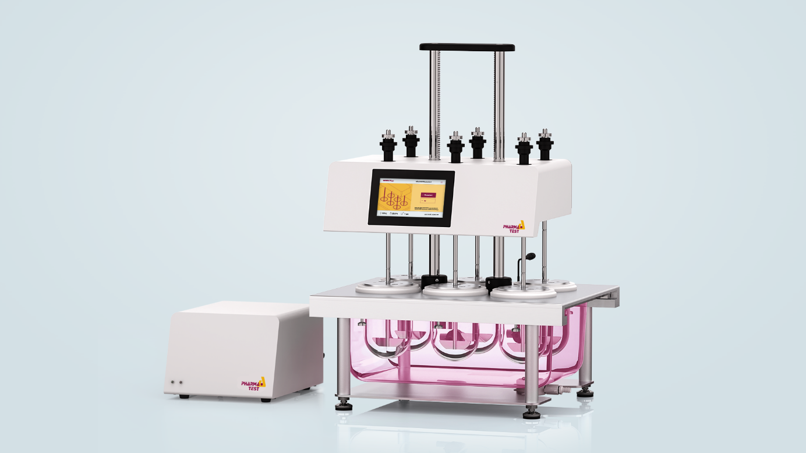
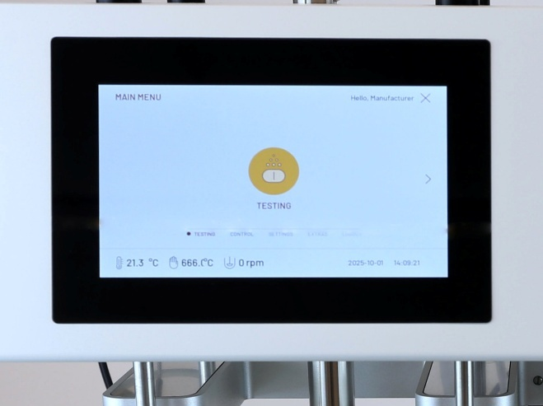 | User Friendly Interface and User Management System  PTWS 130 is equipped with a wide 7-inch color touch screen, designed to enhance usability. The user interface incorporates rich graphical elements, smooth animations, and clear explanatory texts to guide users through every function. The flexible user management system allows for the inclusion of an unlimited number of users, ensuring secure and customized access. Additionally, the system supports an unlimited number of test methods, providing adaptability for a wide range of laboratory needs.
Regulatory Compliance and Audit Trail Features  The audit trail system records all events and changes within the instrument, providing a detailed account with both before and after information, fulfilling the regulatory requirements of 21 CFR Part 11. The audit trail can be filtered using criteria such as date & time, user, method and type of event. | 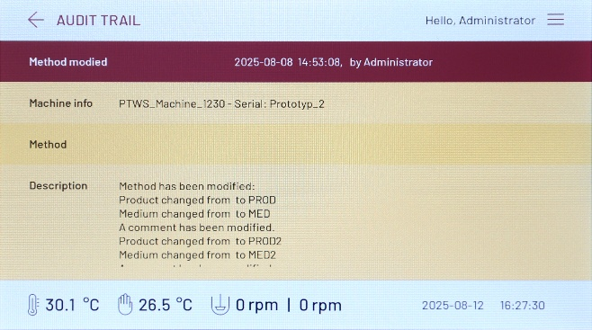
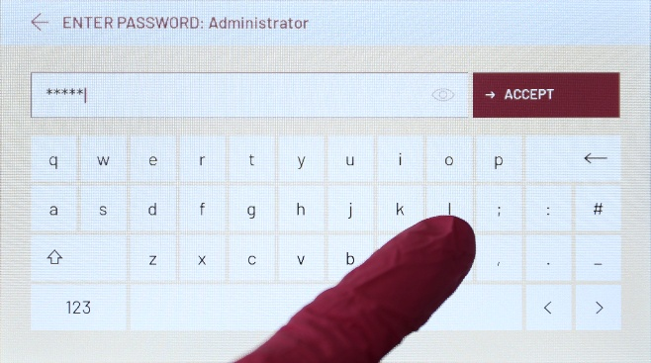 | Touch Screen Operation  All instrument interactions are carried out via a capacitive touchscreen interface, engineered to remain highly responsive even when operated with laboratory gloves. This design not only enhances user convenience but also supports strict hygiene standards in laboratory environments.
Instrument Design for Ease of Use and Reliability  The instrument head features a robust housing constructed from powder-coated stainless steel, ensuring exceptional durability and ease of cleaning. Integrated into the head is a 7-inch touch display, protected by a solid glass plate. This design not only offers a sleek appearance but also provides reliable protection for the display in demanding laboratory environments. | 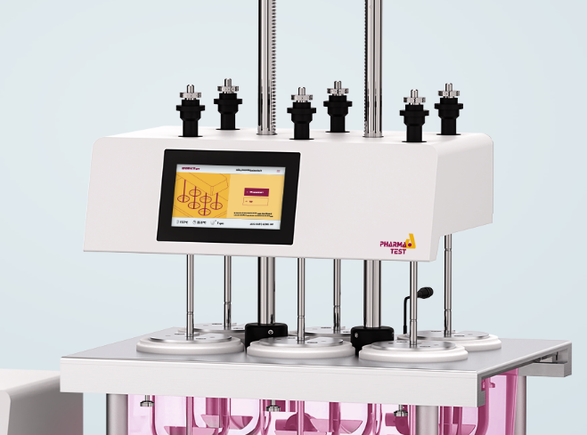
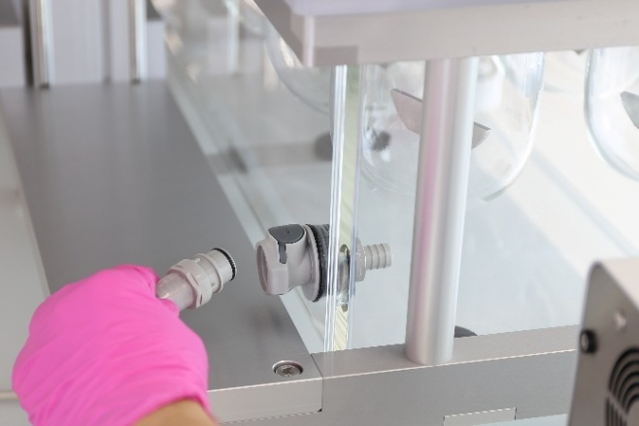 | Quick Connector System  The Plexiglas water bath features a quick-connector system ensuring secure, leak-free attachment of the heater module to the water bath.
Convenient Water-Draining Design  The water bath is designed for convenient emptying and efficient cleaning. The tap connection has been enhanced for increased stability and repositioned to optimize drainage, facilitating more thorough removal of water. Additionally, both the cover and the water bath are removable, allowing for detailed and intensive cleaning when required. | 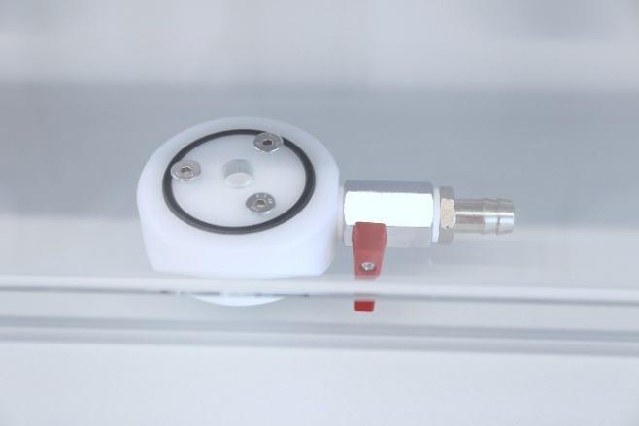
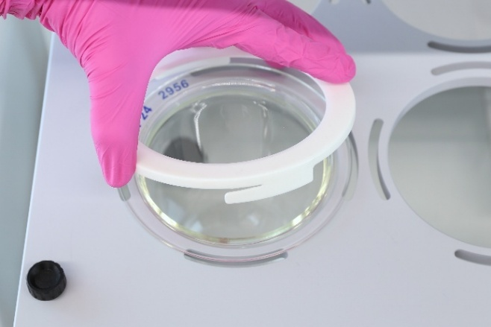 | Sturdy Water Bath Cover System  The water bath cover is constructed from protected Aluminum, offering dimensional stability. Dissolution vessels are inserted into rings fixed to the water bath cover and secured using centering rings equipped with a 3-way bayonet catch mechanism.
Convenient and Precise Electronic Lifter System  PTWS 130 is equipped with a centrally located electronic lifter. It offers the ability to program up to 16 working positions. | 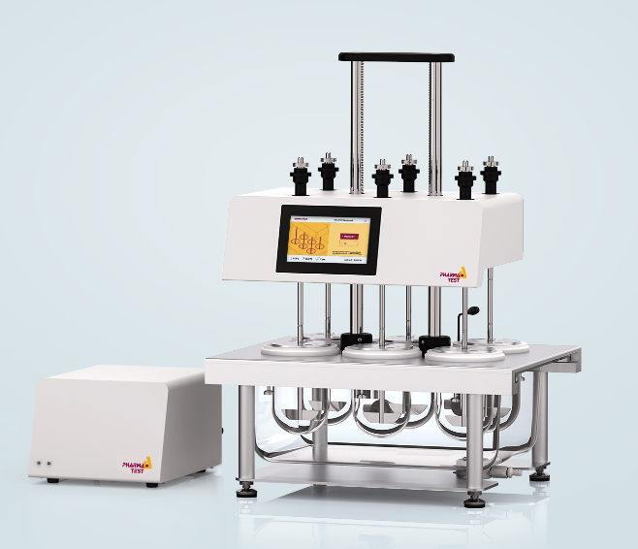
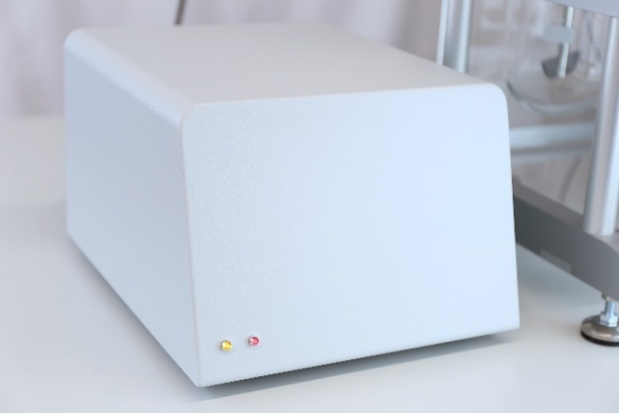 | Heater and Circulation Pump Module Design  The pump and heater are combined into a single external module with a durable, powder-coated stainless-steel housing. The heater module’s internal components have undergone significant advances, incorporating a fully self-contained heating system. This innovation removes the need for a control sensor inside the water bath, simplifying maintenance while ensuring precise and reliable temperature control.
Temperature Sensor and Probe  In addition, an external temperature probe is provided for monitoring the temperature within the vessels or the water bath. The heating system's safety is maintained through an array of internal temperature sensors positioned at both the inlet and outlet of the heater, as well as a resettable thermal cutoff switch. | 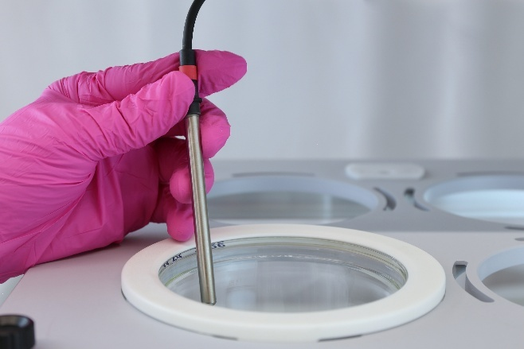

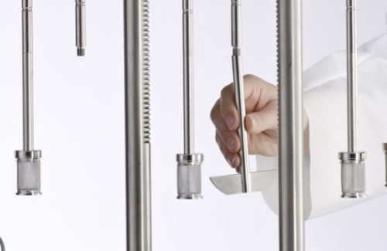 | MonoShaft Stirring Tools and Staggered Start  PTWS 130 uses the Pharma Test MonoShaft design with a main shaft and interchangeable tool heads. The shaft stays fixed in the instrument, keeping tool clearance consistent after initial installation. Each stirrer can be manually lifted for easy vessel access.  PTWS 130 also supports staggered start across its 6 positions, useful in manual mode.
PTWS 130S Variant with Individual Stirring Speed  This instrument version offers individual stirring speed control for each of the six testing stations by means of a dedicated stepper motor for each stirrer. This makes this model ideal for R&D purposes and dissolution method development. | 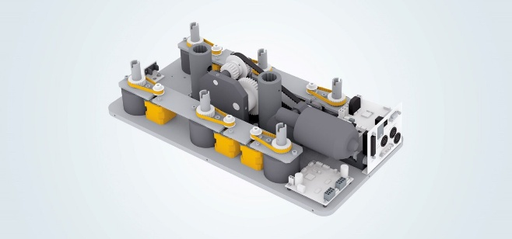

Offline Sampling and Sample Preparation Options
Using PTWS 130 within an automated system offers the operator full access to the vessels before and at the end of a run as the complete drive head is lifted electronically. Sampling sequence timing is programmed using the menu system of the PTWS 130 instrument, while sampling volume and the optional media refilling process are programmed at the fraction collector. The system uses resident sampling probes fixed to the covers of the dissolution vessels. Each sampling probe holds a PP sinter filter (usually 5 or 10µ). When the tablets have been dropped into the dissolution vessels the automated test process starts. If the refilling option is used media refilling will start automatically after a sample has been withdrawn.

Connection to DSR-M Dissolution Sampling Robot and PTFC Fraction Collector
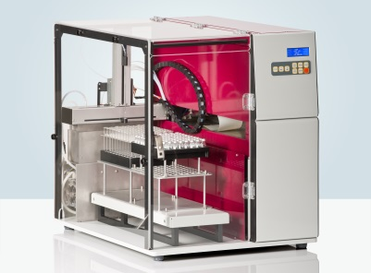 | For offline automation PTWS 130 can be connected to the DSR-M dissolution sampling robot. DSR-M features the capability of sample dilution and media refilling. It offers excellent sampling and refilling accuracy via the fully integrated valve-less piston pump module.
Alternatively, the PTFC-2/8SP fraction collector with PT-SP syringe pumps can be used. No external software is necessary to control either of these systems. | 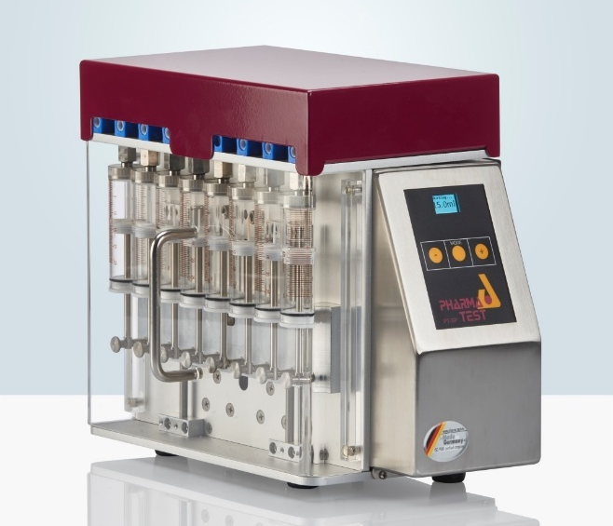

ADS-L Closed Loop Online Automated Systems using Diode Array Spectrometer
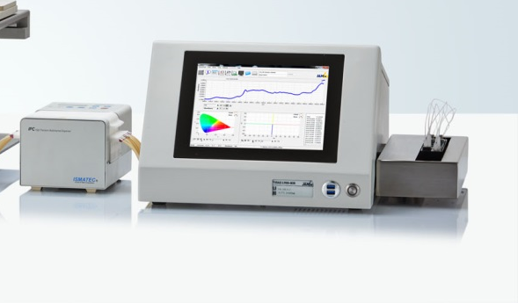 | For an online automated closed loop system the J&M TIDAS L UV/VIS spectrometer with an 8-position multi-cell-changer is the ideal choice. This system is controlled by the powerful WinDiss ARGUS Dissolution software running on the integrated PC of the TIDAS L spectrometer.
The WinDiss ARGUS Dissolution software is a scientific dissolution data management software for instrument control, data acquisition, data management, processing and reporting – designed by users for users. Whether you perform dissolution tests occasionally or several times each day WinDiss ARGUS Dissolution will make you more productive in running tests and analyzing results. | 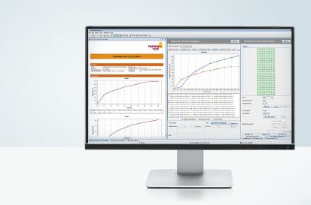

PT-Node Network Adapter for Printing and Data Transfer
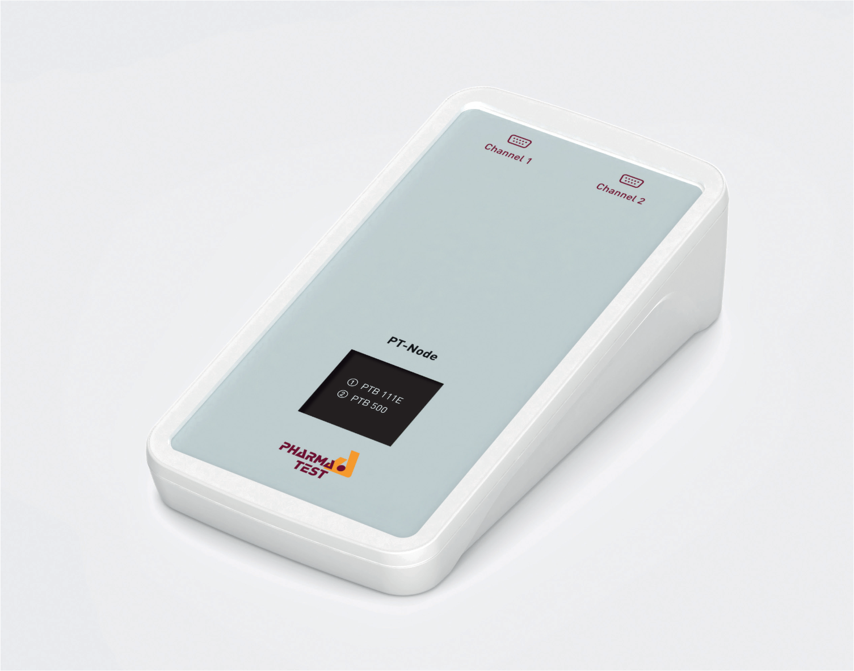 | PT-Node is an adapter that connects up to two Pharma Test instruments simultaneously to a network using a wired LAN connection. This way you can print test results from the instrument via your web browser on any local or network printer. Furthermore, it is possible to transfer the test results from the instruments to external systems in the same network. PT-Node supports PTWS 130.

Example Runtime Report
RUN TIME REPORT  ================  PHARMA TEST PTWS 130D  S/N: 32018  V: 1.00  PRINT DATE/TIME:  02.06.2018 12:31:48  USER NAME: ADMIN  PRODUCT NAME: PRODUCT1  METHOD NAME: METHOD1  BATCH: 1  BATH TEMP NOM.: 37.0  BATH TEMP ACT.: 36.9  LIFT: USP 1  VOLUME: 900ml  DURATION: 0:10  SPEED NOM1: 50  SPEED 1: 50  SPEED NOM2: 100  SPEED 2: 100  I.-COUNT1: 1  I.-DELAY1: 0:01  I.-COUNT2: 1  I.-DELAY2: 0:02  I.-COUNT3: 0  I.-DELAY3: 0:00  TEST STATUS: NO ERRORS  START: 02.02.2026 12:21:08  END: 02.02.2026 12:31:08  INT.1:  02.02.2026 12:22:08  BATH TEMP ACT.: 36.8  INT.2:  02.02.2026 12:24:08  BATH TEMP ACT.: 36.9  OPERATOR NAME  ...............................  SIGNATURE  ............................... | Model of the instrument  Serial number of the instrument  Firmware version installed on the instrument  Date and time of this print out  Name of the user currently logged in  Name of the product used for this test  Name of the method used for this test  Batch number entered at the start of this test  Nominal bath temperature from the method for this test  Actual bath temperature at time of the print out  Name of the lift position from the method for this test  Media volume from the method for this test  Total duration time setting for the method for this test  Nominal speed setting from the method for this test  First interval count  First interval delay  Second interval count  Second interval delay  Third interval count  Third interval delay  Status of the test, if test is still running it will be  “IN PROGRESS”  Start date and time of the test  End date and time of the test (if already finished)  Occurrence of first interval  Date and time of first interval  Actual bath temperature when first interval occurred  Occurrence of second interval  Date and time of second interval  Actual bath temperature when first interval occurred  If no intervals have yet occurred, it will be “NO INT”  Space to write down name of the operator  Space for the operator’s signature

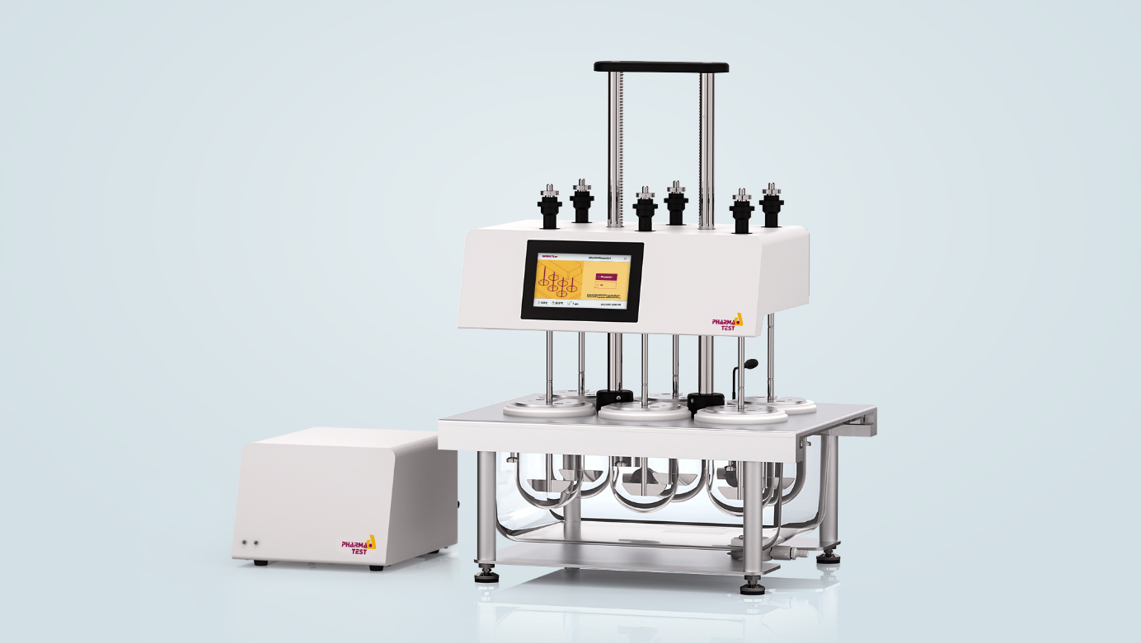

Advantages
- Integrated audit trail ensures 21 CFR Part 11 regulatory compliance
- Flexible user management system with unlimited number of users ensures secure access
- The modern user interface is easy to use and quick to learn
- MonoShaft™ stirring tool design avoids re-adjustment of immersion depth after tool exchange
- Secure and easy to use vessel centering system with bayonet catch
- High flow-through water circulation system for quick heat-up and optimal temperature distribution
- Automatic lift-up at the end of a test for quick access to all vessels
- System is easy to clean thanks to the optimized water bath design
- Wake-up functionality to start heating at a pre-programmed time to reduce waiting times
- Staggered start feature for convenient manual sampling
- Automatic stirrer stop when instrument head is moved
- Modular design to minimize bench space requirements
- IQ/OQ documents included free of charge

Features
- Fully USP <711/724>, EP <2.9.3/4>, BP, DAB and JP <15> compliant
- 6 stirred vessel positions in a 3+3 arrangement
- Centrally located electronic lifter for instrument head with 16 programmable working positions
- Low-evaporation vessel covers with silicone inlay
- Staggered start capability for all testing stations
- Programmable infinity test
- High flow through water circulation design
- Method management and user administration
- Audit trail recording all events and changes with before and after information
- Control of peripheral instruments such as DSR-M Dissolution Sampling Robot or PTFC-2/8SP fraction collector
- Optical and acoustic signals to inform about sampling intervals, timer count down function
- Integrated calibration programs with PQ interval warning

Standard Scope of Supply
PTWS 130 comes ready to use with the following standard scope of supply:
- One set of 6 MonoShaft™ stainless steel stirrers and USP App. 2 paddles
- One set of 6 individually coded 1,000ml borosilicate glass dissolution vessels
- One set of 6 vessel centering rings with bayonet catch
- One set of 6 low evaporation vessel covers with silicone inlay
- One set of 6 depth adjustment balls
- One external temperature probe for water bath and vessels
- One bottle of ALGEX Magenta water preservative
- Comprehensive documentation set including:
  - User manual
  - DQ/QC instrument compliance test report and certificate
  - IQ installation qualification document
  - OQ operation qualification document
  - Instrument logbook
  - Compliance certificates for vessels and stirring tools

Instrument variants
PTWS 130 is available in these model variants:
- PTWS 130D standard 6 station
- PTWS 130S instrument version with individual stirring speed control
- PTWS 130D-2 2-liter dissolution vessel version (can also be used with 1-liter vessels)
- PTWS 130S-2 2-liter dissolution vessel version with individual stirring speed control

Accessories and Options
In addition to the standard scope of supply, Pharma Test offers a broad range of accessories and options including:
- Full range of MonoShaft™ stirring tools available: USP/EP apparatus 1, 2, 5, 6 tool adapter, cream cell, transdermal patch tools, each tool individually coded
- Amber colored vessels, individually coded for UV sensitive test materials
- 250ml MiniVessel set incl. mini paddles
- Ticket printer
- PT-Node network adapter
- Full range of certified validation tools available

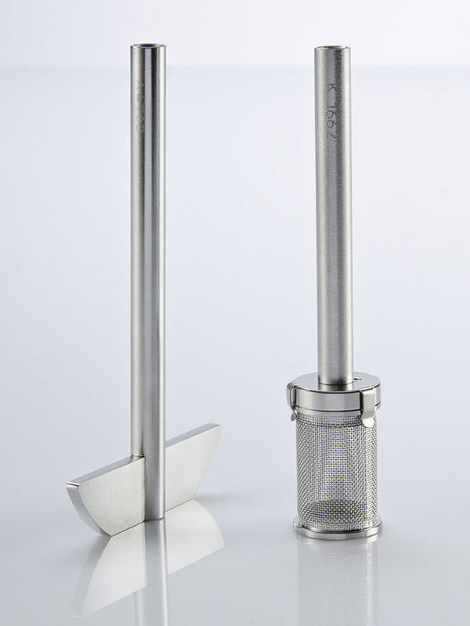

Technical Specifications
Parameter | Specification
Compliance | Fully USP <711/724>, EP <2.9.3/4>, BP, DAB and JP <15> compliant
Number of stirred vessels | 6 (3 by 2 arrangement)
Stirring tool design | MonoShaft™ stirrer design
Stirrer speed range | 25 - 250 RPM
Stirrer speed accuracy | ±2% of set speed, typically < 1%
Stirrer speed settings | PTWS 130D: one common speed setting for all stirrers  PTWS 130S: individual speed setting for each stirrer
Stirrer shaft wobble | Better than 0.2 mm total run out
Heating system | Heating and circulation pump module
Heating range | 25.0 – 45.0°C
Heating accuracy | ± 0.2°C inside the water bath
Display & date entry | 7", 1024x600 pixel resolution color LCD touch screen, backlit
Audit trail | Integrated, logging all events and changes with before and after information, multi-level filtering
User management | Unlimited number of users with password and user rights
Working positions | 16 programmable stirrer immersion positions (paddle over disk, transdermal cylinder etc.)
Method management | Unlimited number of methods
Timer | Programmable sampling times, wake-up and sleeping mode, operation time information and timer count-down mode
Acoustic signal | Programmable acoustic signal for operator information
Calibration & PQ control | Built-in calibration programs with OQ/PQ interval warning
Printer support | External ticket printer or PT-Node network adapter
Interfaces | CAN port for remote control, RS-232 port to connect serial devices, I/O port for remote control of external instruments in automated systems, like DSR-M and PTFC
Instrument dimensions | Bath: approx. 75cm x 45cm x 75cm (width x depth x height)  Heater: approx. 22cm x 32cm x 22cm (width x depth x height)
Net / gross weight | Approx. 75 / 130 kg
Certification | All components certified to USP / EP requirements
CE / EMC certification | All CE / EMC certification provided
Validation | All IQ & OQ documents included
We reserve the right to make technical changes without any prior notice.

